**Slot: L27 + L28 Name: Swaranjana Nayak**

**Date: 06/11/2020 Reg. No.: 19BCE0977**

**CSE2004 LAB FAT**

**Aim:**

To solve the given problems by implementing in SQL.

**QUESTION NO. 3**

**Note**: The following queries are performed in Oracle’s SQL Developer software, instead of command line interface. Rest all queries are same, just output will be in the software’s GUI.

**Note:** There were already such named tables in LOCAL SYS, hence tablename_fat was used to name the table.

1. & 2. Table creation and insertion

Department table

create table department_fat(deptno number(3), deptname varchar2(20), constraint dept_no_pk_fat primary key(deptno));

insert into department_fat values(1, 'SCOPE');

insert into department_fat values(2, 'SITE');

insert into department_fat values(3, 'SELECT');

insert into department_fat values(4, 'SENSE');

insert into department_fat values(5, 'SMEC');

insert into department_fat values(6, 'SCHEME');

select * from department_fat;

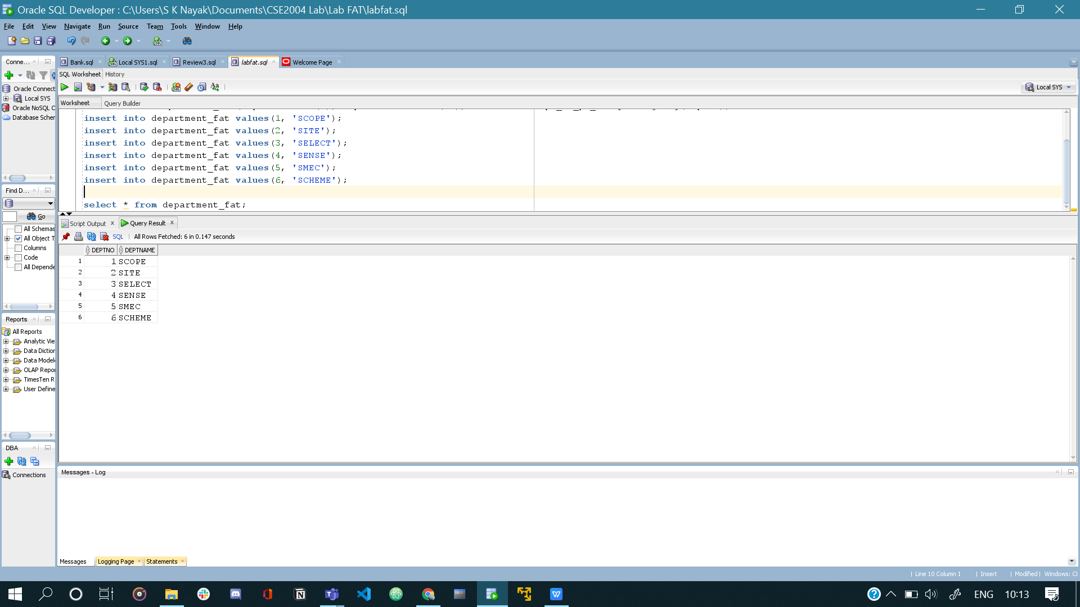

Student table

create table student_fat(regno varchar2(10), name varchar2(20), dob date, address varchar2(20), cgpa number(10, 5), dno number(3),

constraint reg_no_pf_fat primary key(regno), constraint dno_fk_fat foreign key(dno) references department_fat(deptno));

alter table student_fat add constraint cgpa_stu_chk check(cgpa between 2.5 and 10);

insert into student_fat values('19BCE0001', 'Ravi', '12-DEC-1999', 'Pune', 7.9, 2);

insert into student_fat values('19BME0002', 'Rajeev', '12-SEP-1999', 'Hyderabad', 8.9, 5);

insert into student_fat values('19BCE0003', 'Sanjeev', '11-OCT-2001', 'Vellore', 9.3, 1);

insert into student_fat values('19BIT0004', 'Swara', '10-NOV-2001', 'Chennai', 8.3, 2);

insert into student_fat values('19BEE0005', 'Aishani', '13-OCT-2001', 'Bangalore', 9.3, 3);

insert into student_fat values('19BCL0006', 'Raghul', NULL, 'Vellore', 9.3, 6);

select * from student_fat;

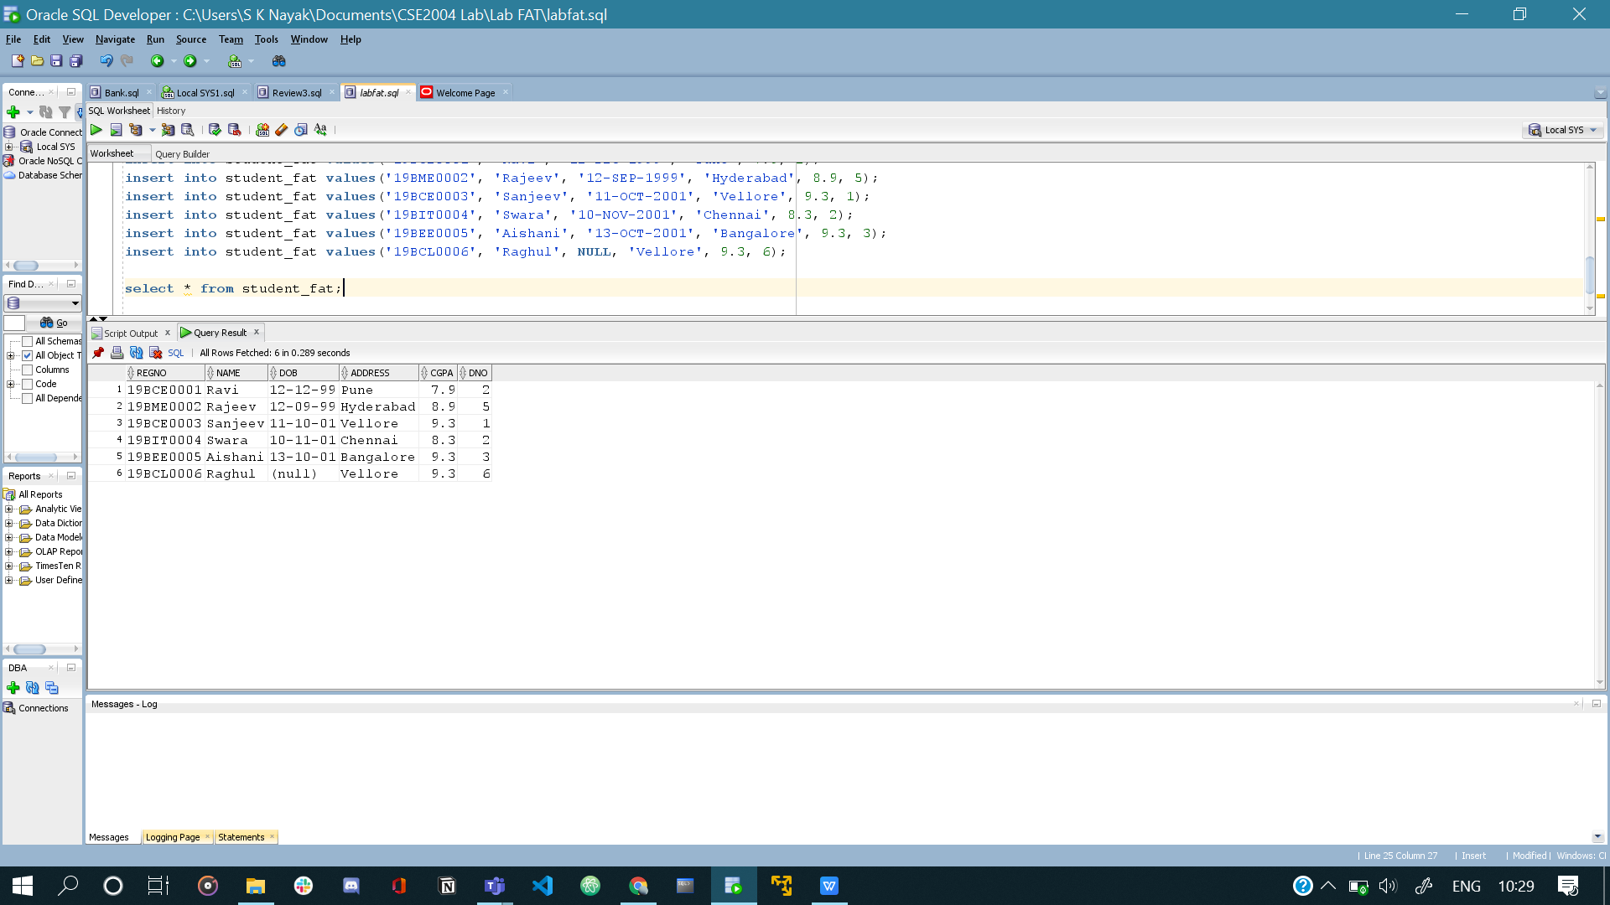

Course table

create table course_fat(code varchar2(10), title varchar2(30) unique, credit number(2), ctype varchar2(10), constraint code_pk_fat primary key(code),

constraint ctype_chk_fat check(ctype in ('PC', 'UC', 'UE')));

insert into course_fat values('CSE2001', 'CAO', 3, 'PC');

insert into course_fat values('BIT2002', 'DBMS', 4, 'PC');

insert into course_fat values('MEE2005', 'Engg drawing', 3, 'UE');

insert into course_fat values('EEE2003', 'Semiconductors', 4, 'UC');

insert into course_fat values('MAT2001', 'Statistics', 4, 'UC');

insert into course_fat values('ECE2004', 'FEC', 4, 'UE');

select * from course_fat;

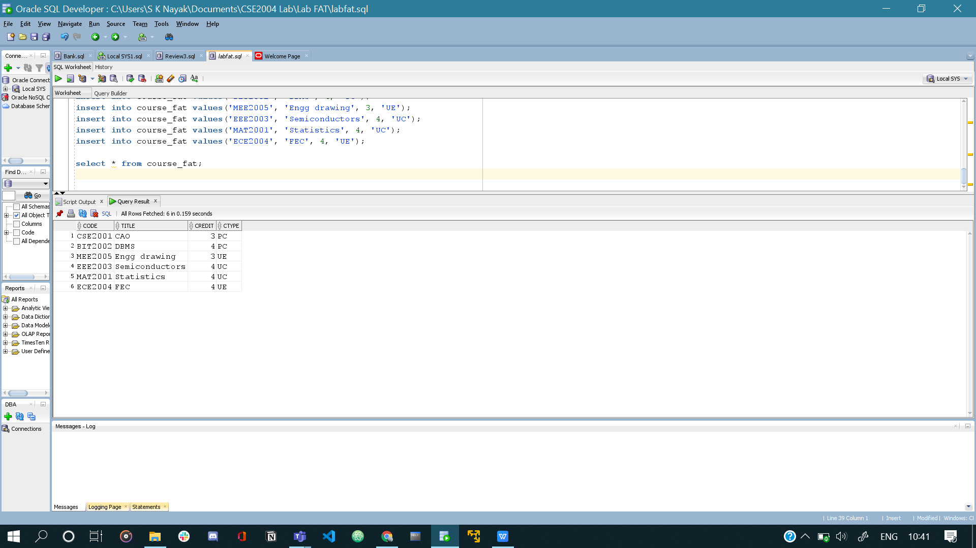

Registered table

create table registered_fat(regno varchar2(10), code varchar2(10), sem varchar2(20), constraint regno_fk_fat foreign key(regno) references student_fat(regno),

constraint code_fk_fat foreign key(code) references course_fat(code), constraint reg_pk_fat primary key(regno, code, sem));

insert into registered_fat values('19BCE0001', 'CSE2001', 'Fall 20-21');

insert into registered_fat values('19BCE0003', 'CSE2001', 'Fall 20-21');

insert into registered_fat values('19BME0002', 'MEE2005', 'Fall 20-21');

insert into registered_fat values('19BEE0005', 'EEE2003', 'Fall 20-21');

select * from registered_fat;

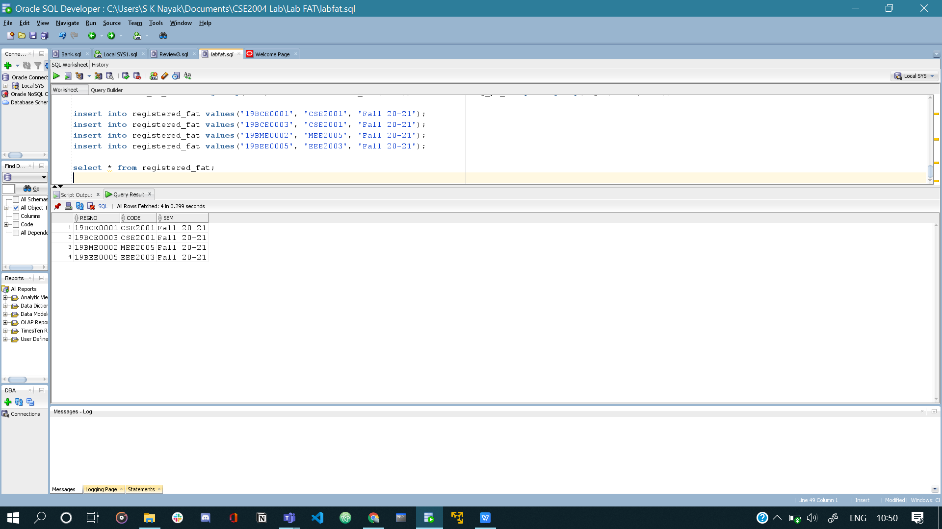

1. delete from student_fat where dob is null;

select * from student_fat;

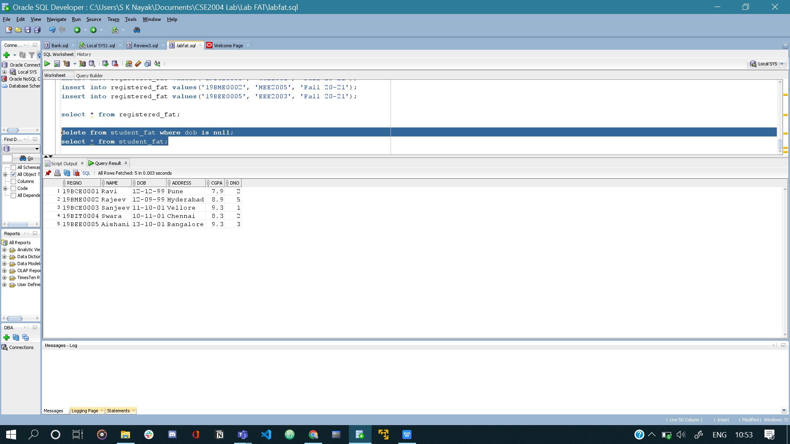

1. A) select deptname from department_fat where deptno in (select deptno from department_fat minus select dno from student_fat);

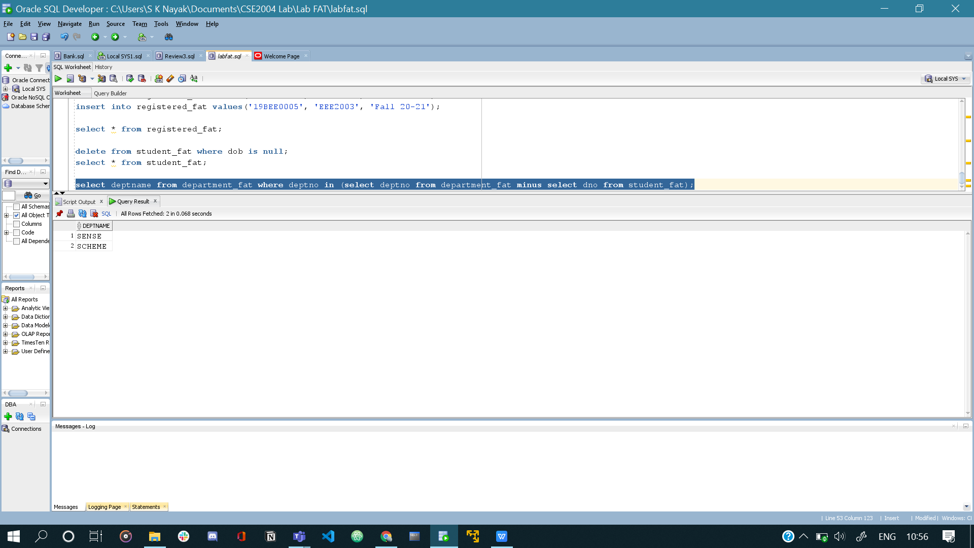

1. select name from student_fat where regno in (select regno from student_fat natural join registered_fat inner join department_fat d on d.deptno = student_fat.dno group by(regno) having count(*) > 2);

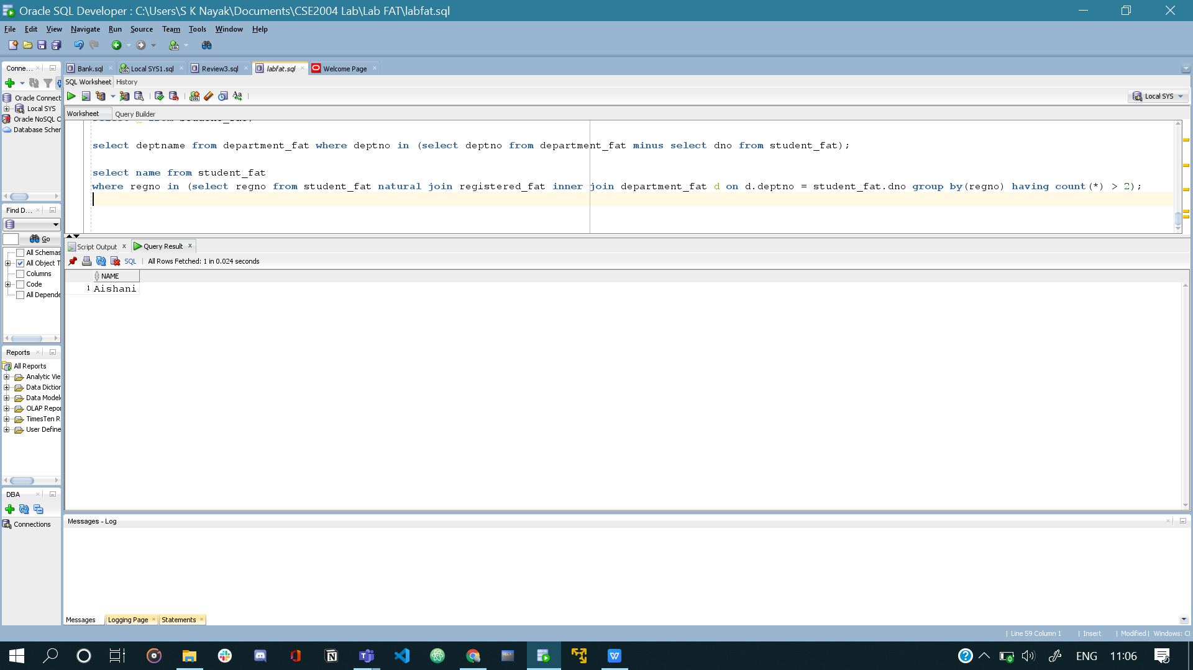

1. select * from student_fat natural join registered_fat where code in (select code from student_fat natural join registered_fat where name = 'Ravi') and name != 'Ravi';

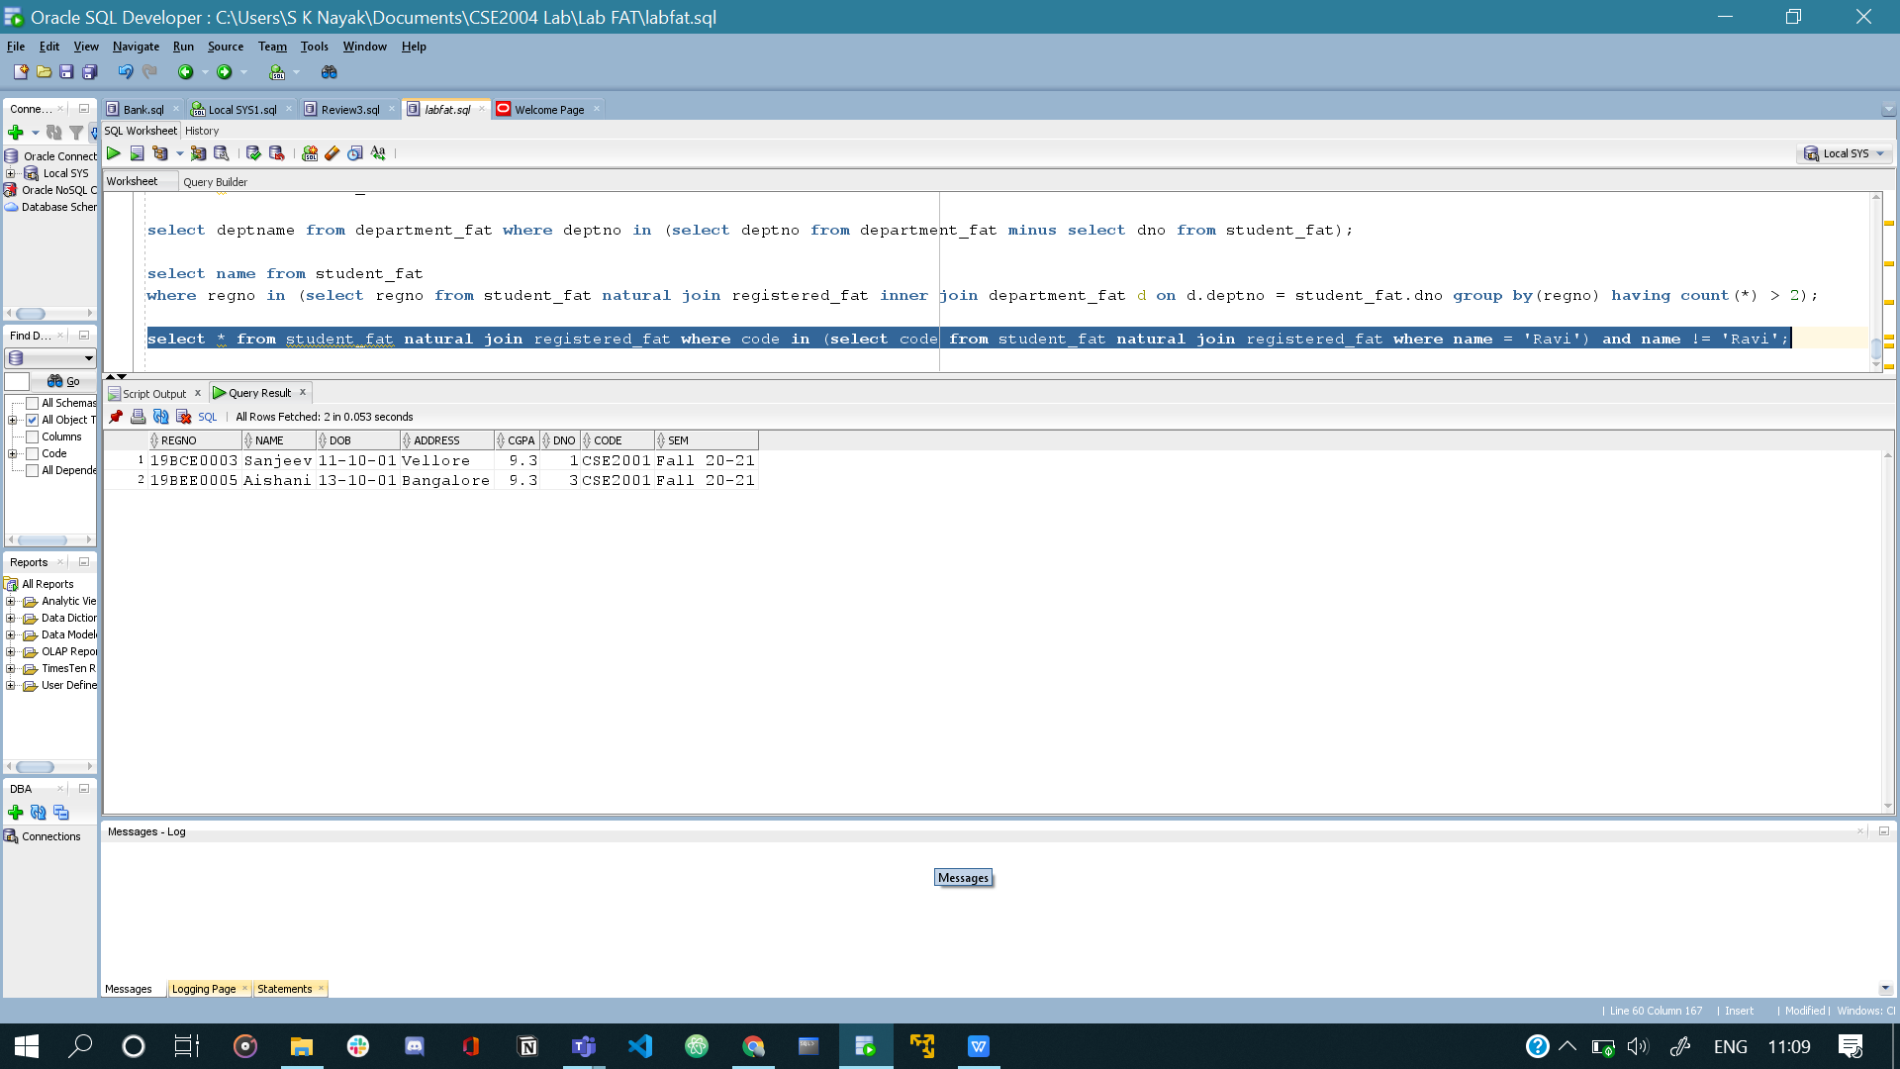

1. select * from student_fat natural join registered_fat inner join department_fat d on d.deptno = student_fat.dno natural join course_fat where name like('R%') and d.deptname != 'SCOPE';

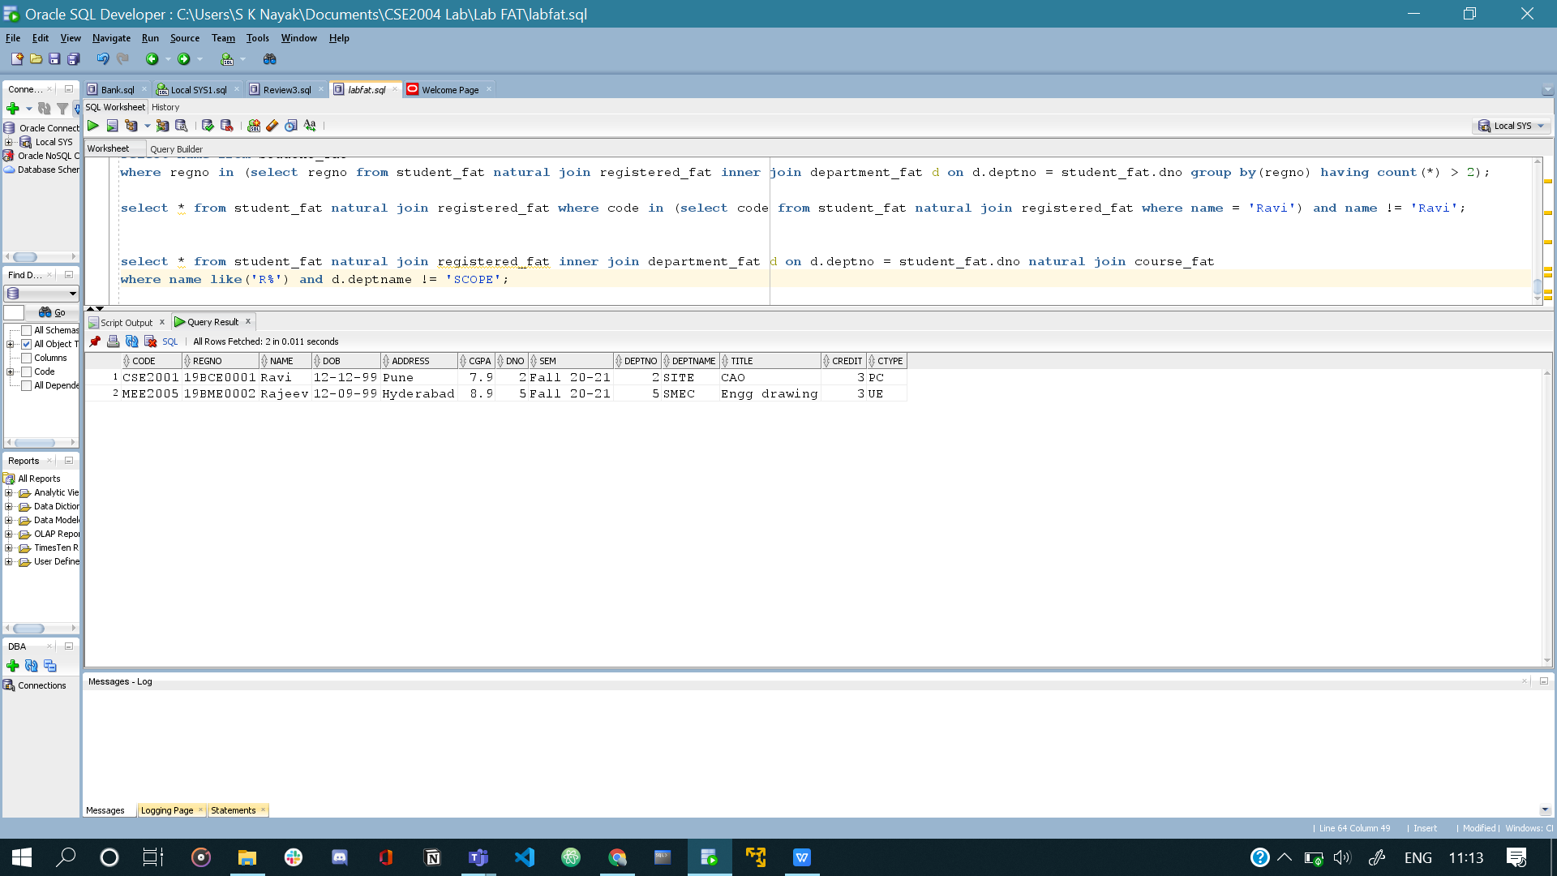

1. Code:

declare

cursor c is select code, credit from course_fat;

code course_fat.code%type;

cred course_fat.credit%type;

begin

open c;

loop

fetch c into code, cred;

exit when c%notfound;

if cred = 4 then

update course_fat set ctype = 'PC' where course_fat.code = code;

dbms_output.put_line('Updated');

end if;

end loop;

close c;

end;

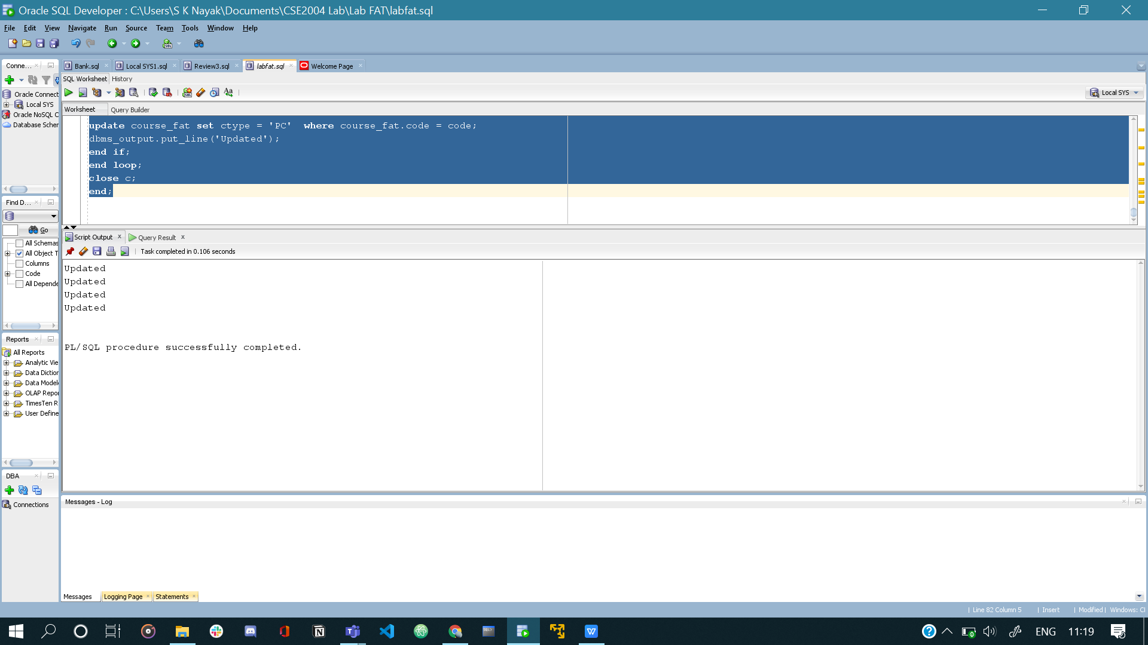

1. Code:

create or replace trigger update_address_student

after update on student_fat

for each row

enable

declare

r student_fat.regno%type := :new.regno;

n student_fat.name%type := :new.name;

d student_fat.dob%type := :new.dob;

a student_fat.address%type := :new.address;

c student_fat.cgpa%type := :new.cgpa;

dn student_fat.dno%type := :new.dno;

begin

dbms_output.put_line(r);

dbms_output.put_line(n);

dbms_output.put_line(d);

dbms_output.put_line(a);

dbms_output.put_line(c);

dbms_output.put_line(dn);

end;

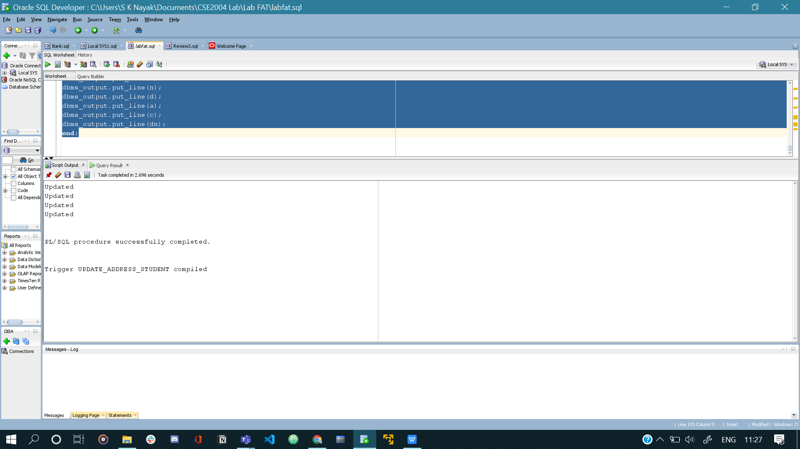

3.alter table student_fat drop column address;

